COMMUNICATION DIAGRAMS

Access Control and Security

1. Login

2. Verification of username/password

3. Multi-factor request

4. MFA code

5. Analytics access

6. Analytics are displayed

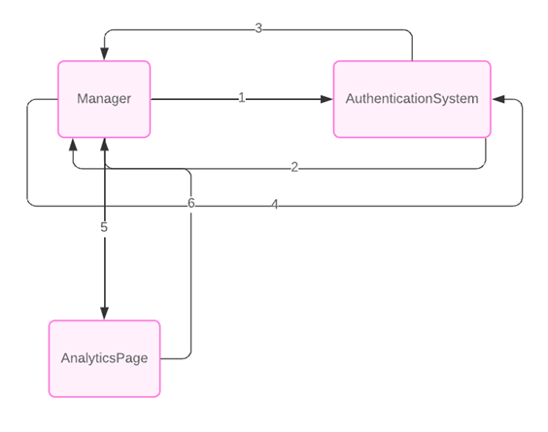

Filtering and Sorting Options

1. Request the options

2. Retrieve filter options

3. Send filter options

4. Retrieve sorting options

5. Send sorting options

6. Display all options

